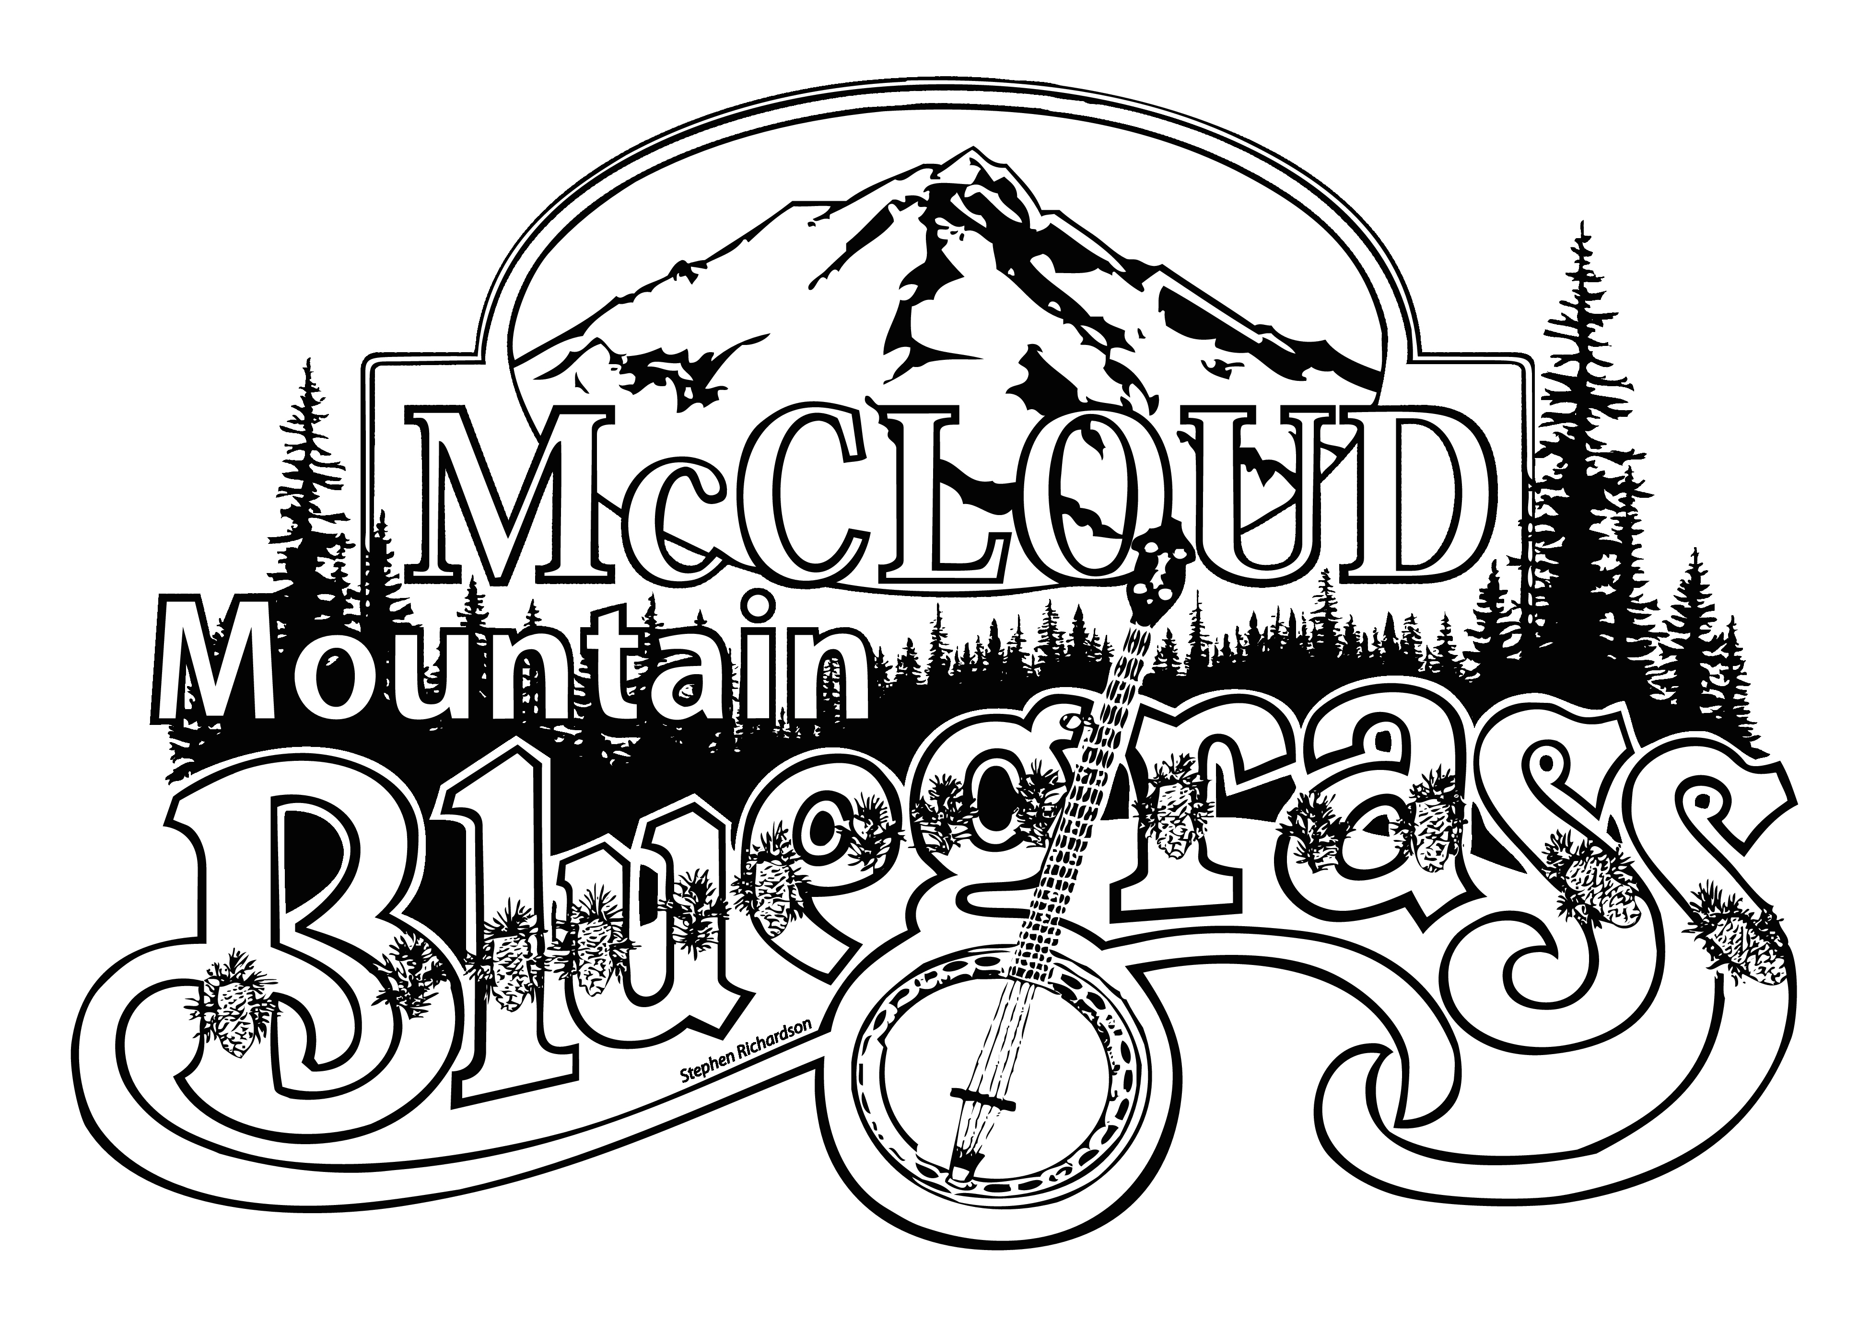
McCloud Chamber of Commerce
McCloud Mountain Bluegrass - September 8, 9, & 10, 2017

P.O. Box 372, McCloud, CA 96057 530-964-3113
www.mccloudchamber.com, search events
info@mccloudchamber.com

Vendor Application

Name:______________________________________________________________________Address:____________________________________________________________________ City:___________________________________ State _______ Zip Code _______________ Email: __________________________________ Phone: _____________________________ Description of Items for sale :____________________________________________________ _________________________________________________________________________________________________________________________________________________________________________________________________________________________________
Food Vendor: 10’x20’ booth space -------- $180 (3 Day Event, 2 Day Minimum)
Food Vendor 10’x20’ booth space: Amount enclosed $ __________________________
Retail Vendor: 10’x10’/20’ booth space ----$80 (3 Day Event, 2 Day Minimum)
Additional Space-------------$70
Retail Vendor 10’x10’/20’ booths requested: _______ Amount enclosed $__________ ______________

Make check or money order payable to McCloud Chamber of Commerce, and mail with Application and Guidelines form (both pages signed) and copy of CA Seller’s Permit to:
McCloud Chamber of Commerce
McCloud Bluegrass
P.O. Box 372, McCloud CA 96057

The McCloud Chamber of Commerce is not responsible for any loss, including but not limited to: theft, injury, property damage, vandalism, or weather. Vendor accepts responsibility for all lost or stolen merchandise and equipment. Vendor accepts all responsibility, liability, and costs for any damage to booth.

Signature:___________________________________________ Date ___________________
VENDOR REPRESENTATIVE

=======================================================================
FOR CHAMBER USE ONLY – PLEASE LEAVE BLANK
Seller’s Permit # _____________________________________________________________
Check/Money order # ________________________ Space #s _________________________
Confirmation email/sent on:________ Vendor Guidelines ______
McCloud Chamber of Commerce
McCloud Mountain Bluegrass - September 10&11, 2016
P.O. Box 372, McCloud, CA 96057 530-964-3113
www.mccloudchamber.com, search events
info@mccloudchamber.com

Vendor Guidelines

McCloud Mountain Bluegrass is open to all legal family-friendly displays, activities, and demonstrations, and must be approved by the Chamber McCloud Bluegrass Committee. Booth space will be pre-assigned and reservations are payable in advance with this application. SPACES WILL BE RESERVED UPON FULL PAYMENT, SIGNED APPLICATION, VENDOR GUIDELINES & SELLERS PERMIT. VENDOR, ___________________________ agrees to abide by the following guidelines;

- The McCloud Chamber of Commerce will locate all booths in a VENDOR AREA. Vendors understand there is no guaranteed placement.

- This is an outdoor event. Tables, chairs, extension cords, booths, canopies, signs, displays or any other equipment will NOT be provided by the McCloud Chamber of Commerce

- Due to the shortage of electrical connections on site, please contact us in advance if your booth will require electricity.

- Booth setup is only between 3 pm and 5 pm Friday September 9, 7 – 9:30 a.m. Saturday September 10. This is a three day event and vendors will not be allowed to remove booth until Sunday September 11 at 4:00 PM.

- Items being sold must be indicated on VENDOR application and approved at the time of acceptance.

- Requests for booth space fee refunds must be made in writing no less than 7 days before the scheduled event. NO REFUNDS WILL BE GIVEN WITHIN 7 DAYS OF THE EVENT.

- DOGS ON LEASH ONLY. No other pets allowed at the event.

- VENDOR will maintain an orderly appearance of rented space(s) during the event, and is responsible for complete cleanup of rented space(s) immediately following the event.

- The McCloud Chamber of Commerce reserves the right to bar any person, persons or business violating the law or Event regulations, or dispensing merchandise from the event that has not been approved by the Chamber McCloud Bluegrass Committee. Any vendor conducting themselves in a manner which would be detrimental to the spirit of the Event will be asked to leave without a refund.

- A copy of your California Seller’s Permit must be prominently displayed at your booth during the event and a copy included with this application. For information regarding a California Seller’s Permit, contact the California State Board of Equalization.

If you have any questions, please call: 530-964-3113, or email info@mccloudchamber.com

Your signature is required below and please remember to sign your check!!

SIGNATURE ______________________________________________ DATE______________________
VENDOR REPRESENTATIVE

